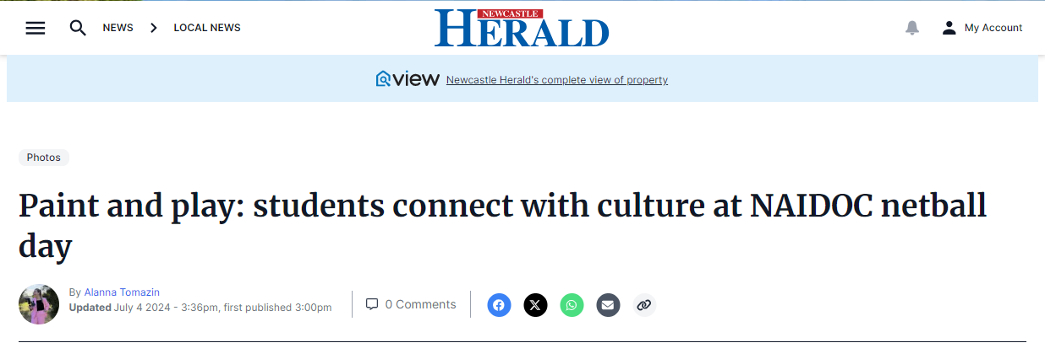
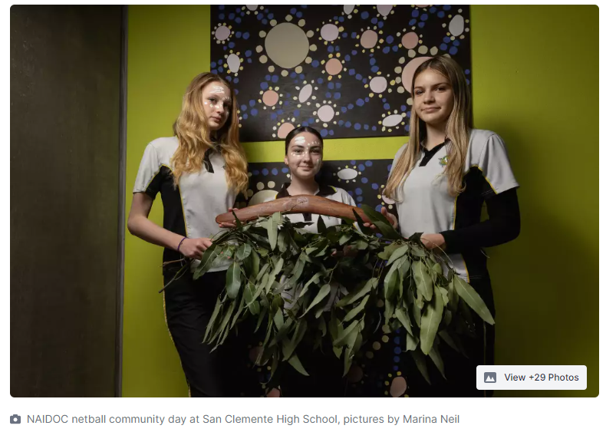
SIX Catholic schools across the Hunter have come together to paint totems and play netball ahead of NAIDOC week celebrations.
St Paul's Booragul, Catherine McAuley Medowie, St Pius X Adamstown, St Joseph's Lochinvar and St Catherine's Singleton visited San Celemente High School in Mayfield on Thursday, July 4 for an Indigenous Community Netball Day.
While some opted for a round robin of netball, others got creative outside in the sun with Torres Strait Islander artist Toby Cedar, to create six artworks representing their school totems, and a seventh piece which incorporates them all.
"We have the main piece which is a dolphin totem and then six boomerangs around it which represents the other schools," year 10 student and proud Dharug woman Lily Ryan said.
"It's reflective of what today is about - connecting with our culture."
The school's Aboriginal food technology students catered the day with a barbecue lunch serving up hungry netball players throughout the afternoon.
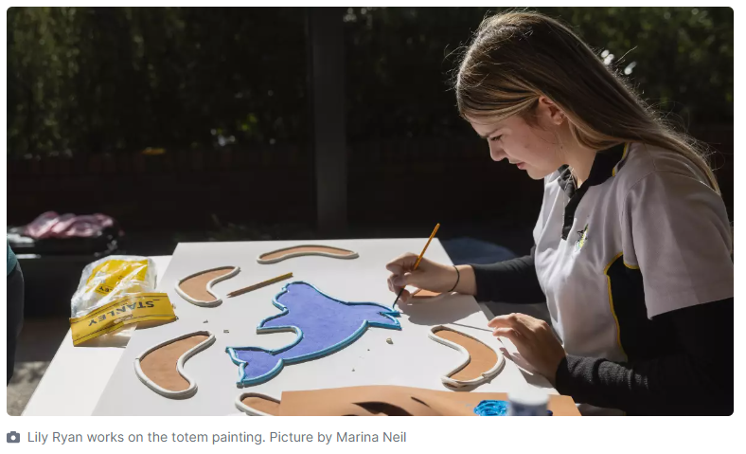
"This morning we made coffee for teachers and then did some sausage sangas for the students," student and proud Worimi woman Bonnie Kopec said.
The idea to host an Indigenous Community Netball Day came from former San Clemente student Isabelle Pulbrook who started the first event in 2023.
Now a year 11 student at St Francis Xavier Hamilton, she was invited back by her old school to help out on the day.
"I'm super proud. My friends and I organised this and we didn't think it would turn into a big thing. I'm so happy to see it make a return and be involved," she said.
She hopes to see it grow in the future and incorporate more sports like rugby league, soccer or basketball.
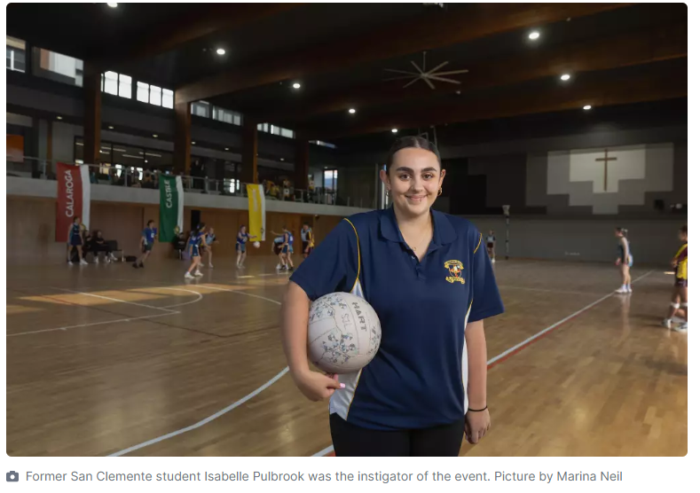
This year's NAIDOC theme is Keep the Fire Burning! Blak, Loud & Proud and San Clemente Aboriginal Education teacher Bryan Rowe said the netball day was a great way for students to engage in the theme.
"... because sports are a great way to get people moving, keeping their energy up. It really stokes that fire and it allows the students to build on their connections," he said.
NAIDOC Week 2024 runs from July 7 to July 14 this year.
