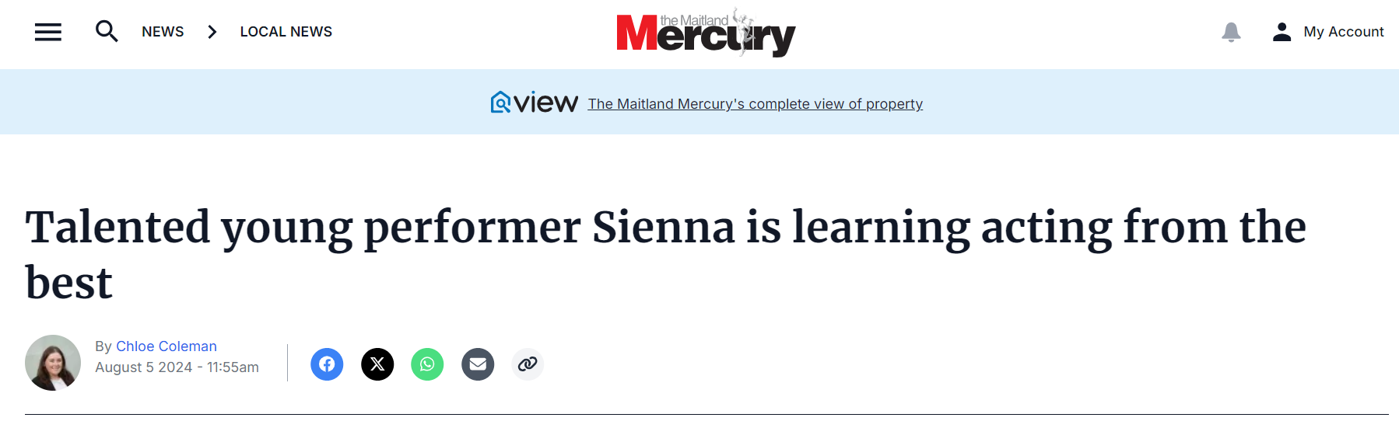
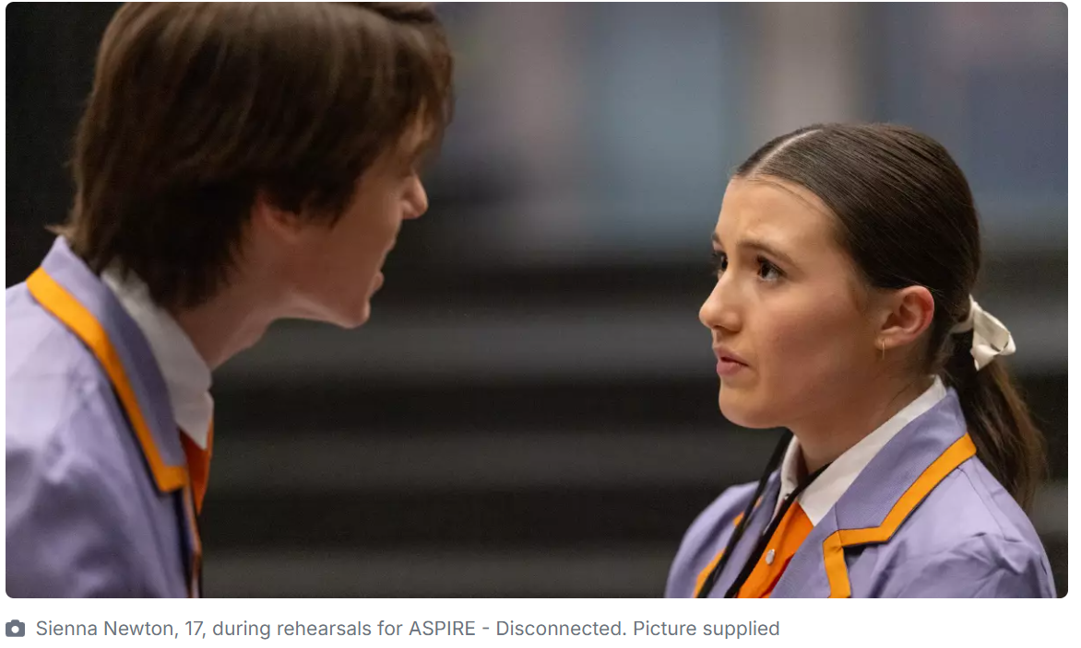
Young performer Sienna Newton has been learning from the best in the business after successfully auditioning for the NIDA Young Actors Studio program.
The All Saints' College, Maitland year 11 student has been spending her weekends travelling to Sydney for her classes, where she learns acting techniques and develops her skills.
Sienna said it's a great opportunity to be a part of the program.
"It's pretty full on, at first it's a bit of a shock because you're working with people basically in the industry, a lot of our tutors are actually working actors and they've taught at NIDA for years and years, so it's a pretty cool opportunity to learn new skills and whatnot," she said.
Sienna auditioned for NIDA (National Institute of Dramatic Art) in December 2023 and was one of 16 successful performers out of 60 who auditioned.
During the audition process, she performed a monologue from Shakespeare's The Two Gentlemen of Verona, and went through drama some exercises.
The program has a different focus each term, and runs on Saturdays for eight weeks per school term, for the year.
"In term one we focused on ensemble building with the 16 of us, and then we did our movement and voice work in the afternoons," she said.
"Last term we worked with classical texts and contemporary scenes, so we did a little mini performance for friends and family at the end of the term, and then this term we're doing audition techniques and then we're doing devising, so basically we get to do another little showcase at the end of this term as well."
Sienna said while she is trained in musical theatre, her main goal is to become an actor.
"I'm hoping at the end of next year to audition for NIDA, for a few of their degrees and probably go over to WAAPA (Western Australian Academy of Performing Arts) as well which is in WA, and audition around and just give myself as many opportunities as possible to get in the industry," she said.
Sienna attends the Young People's Theatre in Hamilton every week for musical theatre and singing lessons, and also attends dance lessons in Maitland.
She has just performed in the Catholic School's Office's ASPIRE production, where she had a major role as the older sister of the main character.
