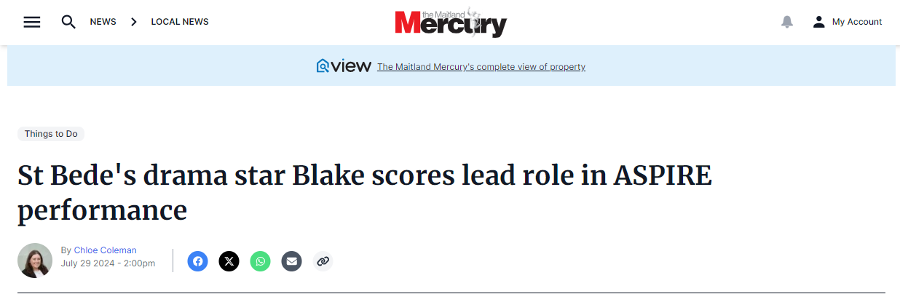
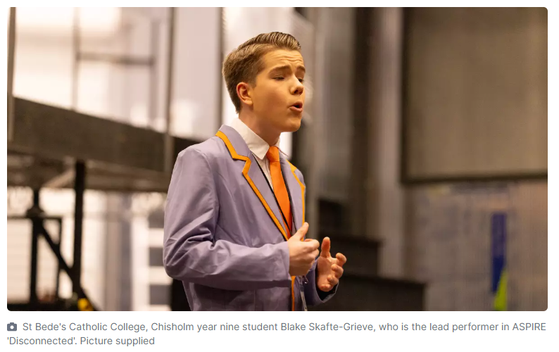
A 15-year-old from Maitland has landed the lead role in this year's ASPIRE production Disconnected.
Blake Skafte-Grieve, who is in year nine at St Bede's Catholic College, Chisholm, plays Daniel, who lives in a town where no one cares that the town crier has been fired and everyone is obsessed with their phones - until the internet is mysteriously cut off.
The production, which opens at the Civic Theatre on Wednesday, July 31, features an original script with a great soundtrack.
The show brings together more than 150 students from schools across the Diocese of Maitland-Newcastle in drama, singing, acting, music, design and crew roles.
Blake said his character aspires to be a town crier and is very passionate about it.
"Basically in the show the internet goes out and Daniel's job is to find another way to communicate with everyone and he uses town crying as a way to do that," he said.
"There is definitely a lot of acting in the role and there is a little bit of movement as well."
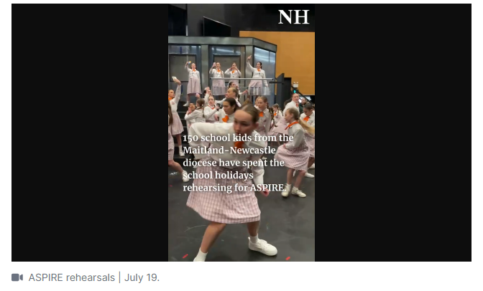
This is Blake's fourth ASPIRE production, and lots of fellow St Bede's students are involved in drama, singing, band and design.
Blake said rehearsals are going well and it's a great opportunity to learn from other creatives and make friends. His favourite part of the process so far has been getting to see all the different parts of the show come together.
"I think bringing it all together, because at the start of rehearsals you're just working with your group, like the drama group, but when you bring it all together and you get to see the singing, and the dancing, and put it all together with the set and all the creative aspects, it makes it really good and you get to really see how amazing it all is," he said.
Blake has been performing since he was four-years-old, which is about the same time he was declared Dreamworld's mini mayor, a role that had him remembering lines and answering interview-style questions to help promote the theme park.
Outside of school, he is heavily involved in Gosford Musical Theatre Society where he has performed in productions of Aladdin, Frozen and Charlie and the Chocolate Factory.
St Bede's creative and performing arts (CAPA) leader of learning Michelle Burgess said Blake is heavily involved with performing arts at school.
The show is on for four performances from July 31 to August 3. Get tickets (from $30) at civictheatrenewcastle.com.au/what-s-on/all-shows/aspire-program-presents-disconnected.
