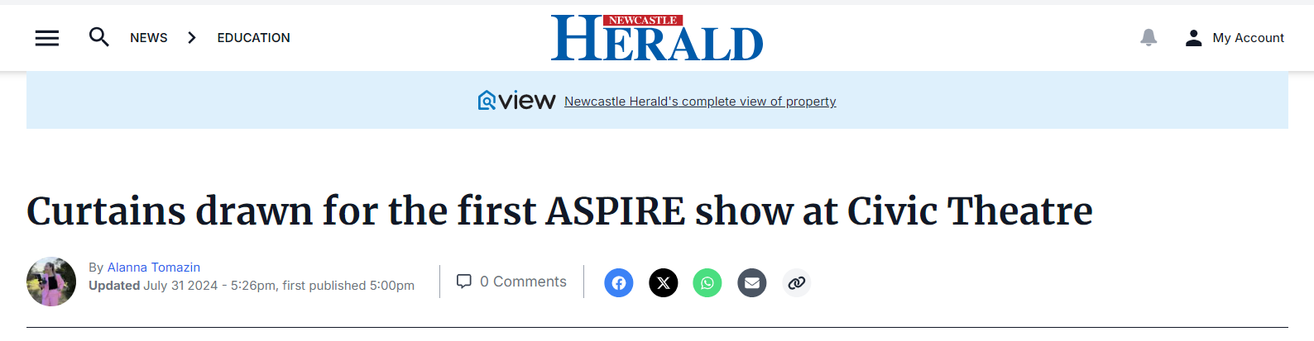
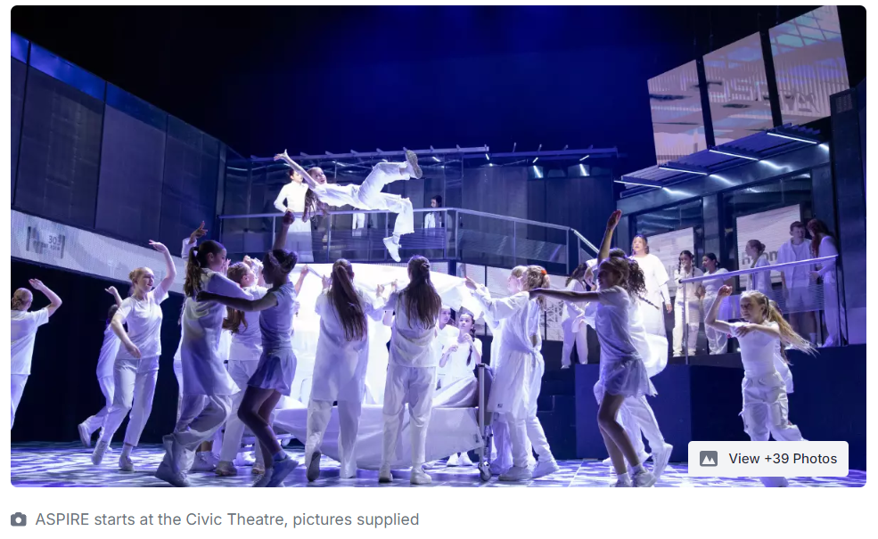
AFTER months of preparation, the curtains were drawn at the Civic Theatre on Wednesday for the first of five ASPIRE Program shows.
From July 31 to August 3, more than 150 students across the Hunter Catholic diocese will perform their production called Disconnected.
St Pius X Adamstown senior drama student Joshua Wolfson said the first show was almost a full house with just nine tickets left.
"It went really well. We performed to a primary school audience and they're always great and responsive to everything," he said.
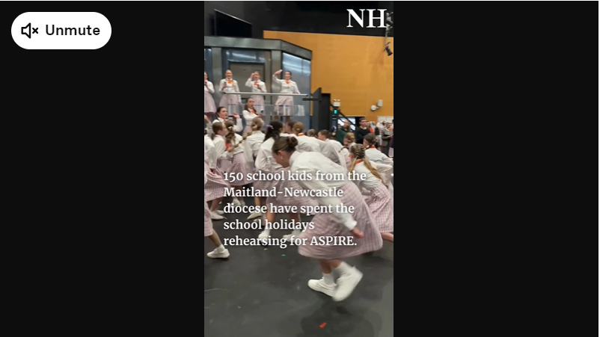
He said there were a few nerves among the cast but, once they stepped centre stage, everything was smooth-sailing.
"It was so good to see how it all came together, showcasing our talent giving it a crack and getting up there," he said.
The show is entirely steered by students under the guidance of an artistic director and follows a story about a town crier who has been fired and finds that nobody cares, as they're all too consumed by their phone screens, until the internet is mysteriously cut off.
Mr Wolfson encouraged people to see the four remaining shows with tickets still available from the Civic Theatre website and box office.
