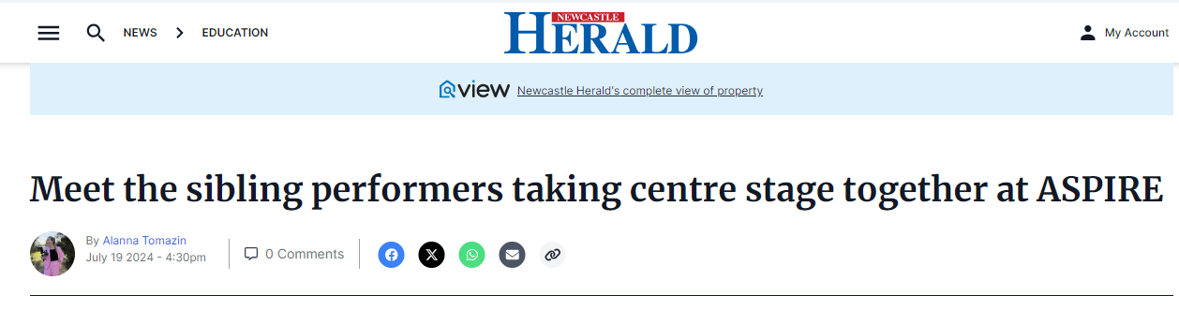
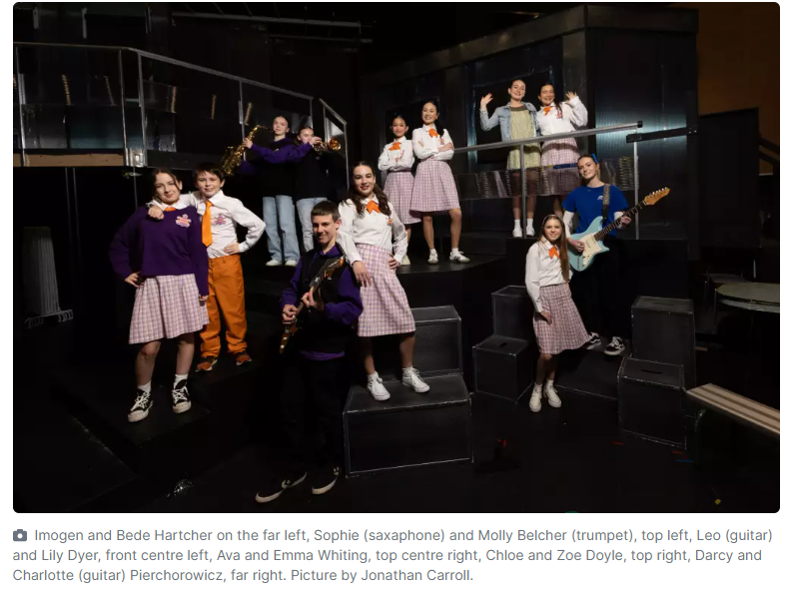
THERE'S no one that has your back quite like your sibling, and when you're about to perform in front of a large crowd, it's nice knowing you've got someone in your corner to calm the nerves.
This year a record number of siblings are stepping centre stage at the Civic Theatre for the 2024 ASPIRE Program kicking off from July 31 through to August 3.
"It's good to know I have someone that is close to me," 15 year-old Charlotte Pierchorowicz said about her younger sister Darcy, 12.
"I think we both have always been very creative and it's good to have our own sort of thing, but be able to do it together," she said.
The St Mary's Catholic College students have spent the second half of their school holidays with more than 150 students across the Hunter Catholic diocese, rehearsing ahead of opening night.
"ASPIRE definitely pushes us to be the best we can and grow as performers," Darcy said.
The students have been running lines, perfecting their positions and doing last minute costume checks in their respective dance, vocal, design, acting and instrumental ensembles.
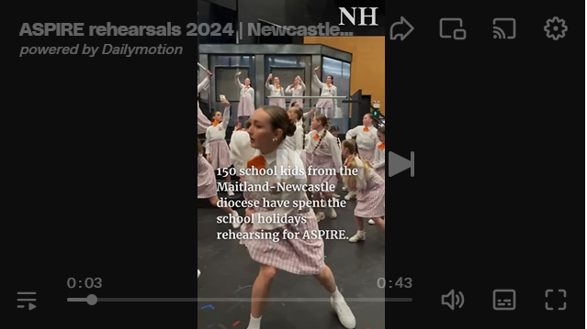2
"The most fun we've had is creating relationships with others and we're looking forward to seeing how the whole thing looks once we're on stage," Darcy said.
Sisters Cleo, 16 and Zoe, 14 are both in the dance ensemble and have done five ASPIRE shows together.
"We used to be in the same troops at dance and we dance together and practice together," Zoe said.
"I love dancing with Cleo she's always fun and having her lead, I like to watch her grow. It's really fun working with someone that you're very close to," she said.
All Saints College Maitland student Leo Dyre, 15 plays the guitar and has been helping his sister Lily, 14 practice her singing for the show.
"It's great, we get to talk about our rehearsals after we do them and even practice together," Leo said.
"While he plays guitar, I start singing. We'll do it with a backing track, and then he'll play his part along with the backing track, and I'll just sing my part," Lily said.
This year's production is called Disconnected, which follows a story about a town crier who has been fired and find that nobody cares as they're all too consumed by their phone screens, until the internet is mysteriously cut off.
The show is entirely steered by students under the guidance of an artistic director.
Tickets are available for purchase from the Civic Theatre website and box office.
