Wednesday, 15 July 2020

Praying for lasting peace 75 years on
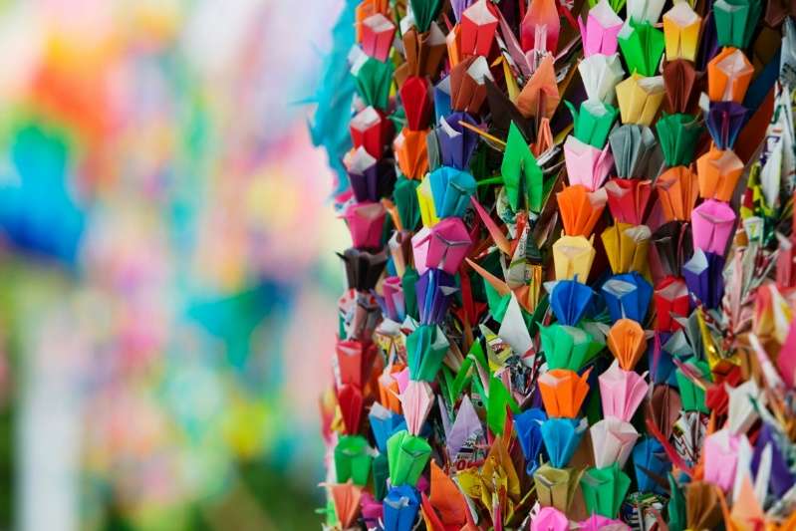
The Uniting Church Assembly in partnership with the Nobel Peace Prize-winning International Campaign to Abolish Nuclear Weapons (ICAN) will host an online interfaith service on 6 August marking 75 years since the nuclear attacks on Hiroshima and Nagasaki.
The horrific explosions resulted in more than 200,000 deaths and countless injuries. The impacts are still felt today, with many survivors requiring ongoing care.
The service will include prayers from different faith traditions to honour the victims and survivors of nuclear weapons use and testing worldwide.
Prayers will also focus on our common hopes for a peaceful world free from nuclear weapons. There are still almost 14,000 nuclear weapons held between nine countries today. Every single one represents a catastrophic disaster, either by accident or design, that must be prevented.
Encouraging people of faith to join the service, UCA President Dr Deidre Palmer said, “As Christians, we are called by God to love our neighbours and to work for an end to violence. Nuclear weapons threaten the survival of humanity and our living planet. They breed relationships of distrust and fear.”
“Rather, we seek to build a world transformed by hope, peace and justice where the sacredness of all life is protected.”
ICAN Australian Director Gem Romuld will speak about the ongoing campaign to eradicate nuclear weapons and work towards the global treaty which comprehensively bans nuclear weapons and any activities that support them. Currently 39 countries have ratified the Treaty. Australia is yet to sign on.
Pacific Conference of Churches General Secretary Rev. James Bhagwan will speak about the impacts of nuclear testing across the Pacific in the 50 years since the end of World War II.
“Their impact on the fragile ecology of the region and the health and mental wellbeing of its peoples has been profound and long-lasting,” said Rev. Bhagwan. “The world must end any possibility of nuclear war; there must be no chance of even one weapon being ever detonated
The service is on Thursday 6 August, at 6-6.45pm. Register here to join the service by Zoom: https://actionnetwork.org/events/interfaith-service-for-nuclear-disarmament

The service will also be shared live on the Assembly Facebook page.

